**R Programming:** **Time Series Analysis and Modelling**

**Project File**

**Submitted for the partial fulfilment of the degree of**

**Bachelor of Technology**

**In**

**Mathematics and Computing**

**Submitted By**

**Shivam Singh**

**Submitted To**

**Ms. Manali Singh**

**Assistant Professor**

**Department of Engineering Computer Science**



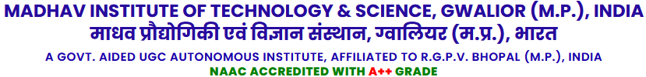

**July-December 2024**

**ABSTRACT**

Time series analysis and forecasting have become pivotal in various domains, including finance, healthcare, climate studies, and business analytics. This project presents an interactive **Time Series Analytics Dashboard** built using Shiny, Plotly, and statistical modeling tools like ARIMA and ETS. The primary objective is to provide an intuitive platform for users to analyze, visualize, and forecast time series data.

The dashboard supports popular datasets, such as AirPassengers, CO2 levels, and temperature series, allowing users to explore trends, seasonal patterns, and decomposition of data. Features include customizable parameter selection, statistical tests like ADF and KPSS, and model evaluation using metrics like MAPE and RMSE. Users can interact with decomposed components, visualize actual vs. forecasted data, and assess the performance of forecasting models in real-time.

This project demonstrates the integration of statistical rigor and modern visualization techniques, making it a practical tool for researchers and analysts. By automating key processes and offering flexibility, the solution paves the way for efficient time series forecasting while highlighting areas for future improvements, such as integrating advanced machine learning techniques.

**ACKNOWLEDGEMENT**

I extend my heartfelt gratitude to **Miss Manali Singh**, from the **Computer Science and Business Department**, for her invaluable mentorship and guidance throughout this project. Her expertise in data analytics and visualization, coupled with her constructive feedback, played a pivotal role in the successful completion of this work. Her unwavering support and encouragement inspired me to explore innovative solutions and achieve a high standard of excellence in this project.

I am also deeply thankful to my mentors, faculty members, and peers for their continuous support and insightful suggestions during the development phase. My sincere appreciation goes to the open-source community for providing essential tools and libraries like shiny, ggplot2, and forecast, which were fundamental in realizing this project. Lastly, I thank my family and friends for their patience and motivation, which kept me focused and determined throughout this journey.

|  |  |  |  |
| --- | --- | --- | --- |
| **S. No** | **Name** | **Roll No.** | **Signature** |
| **1.** | **Sanskar Gupta** | **0901MC211055** |  |
| **2.** | **Sanskar Makkar** | **0901MC211056** |  |
| **3.** | **Saurabh Mishra** | **0901MC211057** |  |
| **4.** | **Shaily Singh** | **0901MC211058** |  |
| **5.** | **Shivam Singh** | **0901MC211059** |  |
| **6.** | **Siddharth Gubrele** | **0901MC211060** |  |

**CONTENT**

1. Introduction
2. Dataset Overview
3. Understanding Time Series Analysis
4. Technologies and Tools
5. Data Modelling Approach
6. Building the Time Series Model
7. Model Evaluation
8. Results and Analysis
9. Challenges and Limitations
10. Conclusion and Future Work
11. References

**INTRODUCTION**

Time series data is pivotal in understanding trends, seasonality, and forecasting for industries like finance, healthcare, and transportation. This project leverages Shiny to create an interactive dashboard for performing time series analytics efficiently. Users can select datasets, configure model parameters, visualize time series behaviour, and generate forecasts interactively. The integration of ARIMA modelling ensures robust and reliable forecasts.

**1.1 Project Background**

Time series analysis and forecasting play crucial roles in modern business decision-making. This project addresses the need for accessible, interactive tools that can handle complex time series data analysis while providing intuitive visualizations and insights.

**1.2 Project Objectives**

* Develop an interactive dashboard for time series analysis
* Implement robust statistical methods for forecasting
* Provide user-friendly interfaces for data exploration
* Enable real-time model adjustments and visualization
* Generate actionable insights from time series data

**1.3 Project Scope**

The project encompasses:

* Development of a Shiny dashboard
* Implementation of time series analysis methods
* Integration of multiple visualization techniques
* Statistical testing and model validation
* User interface design and optimization

**1.4 Key Features of the Dashboard:**

* Visual exploration of time series data.
* Decomposition of trend, seasonal, and residual components.
* Model fitting using ARIMA with options for seasonal adjustment and Box-Cox transformation.
* Forecasting for user-defined periods.
* Evaluation of model accuracy with statistical metrics.

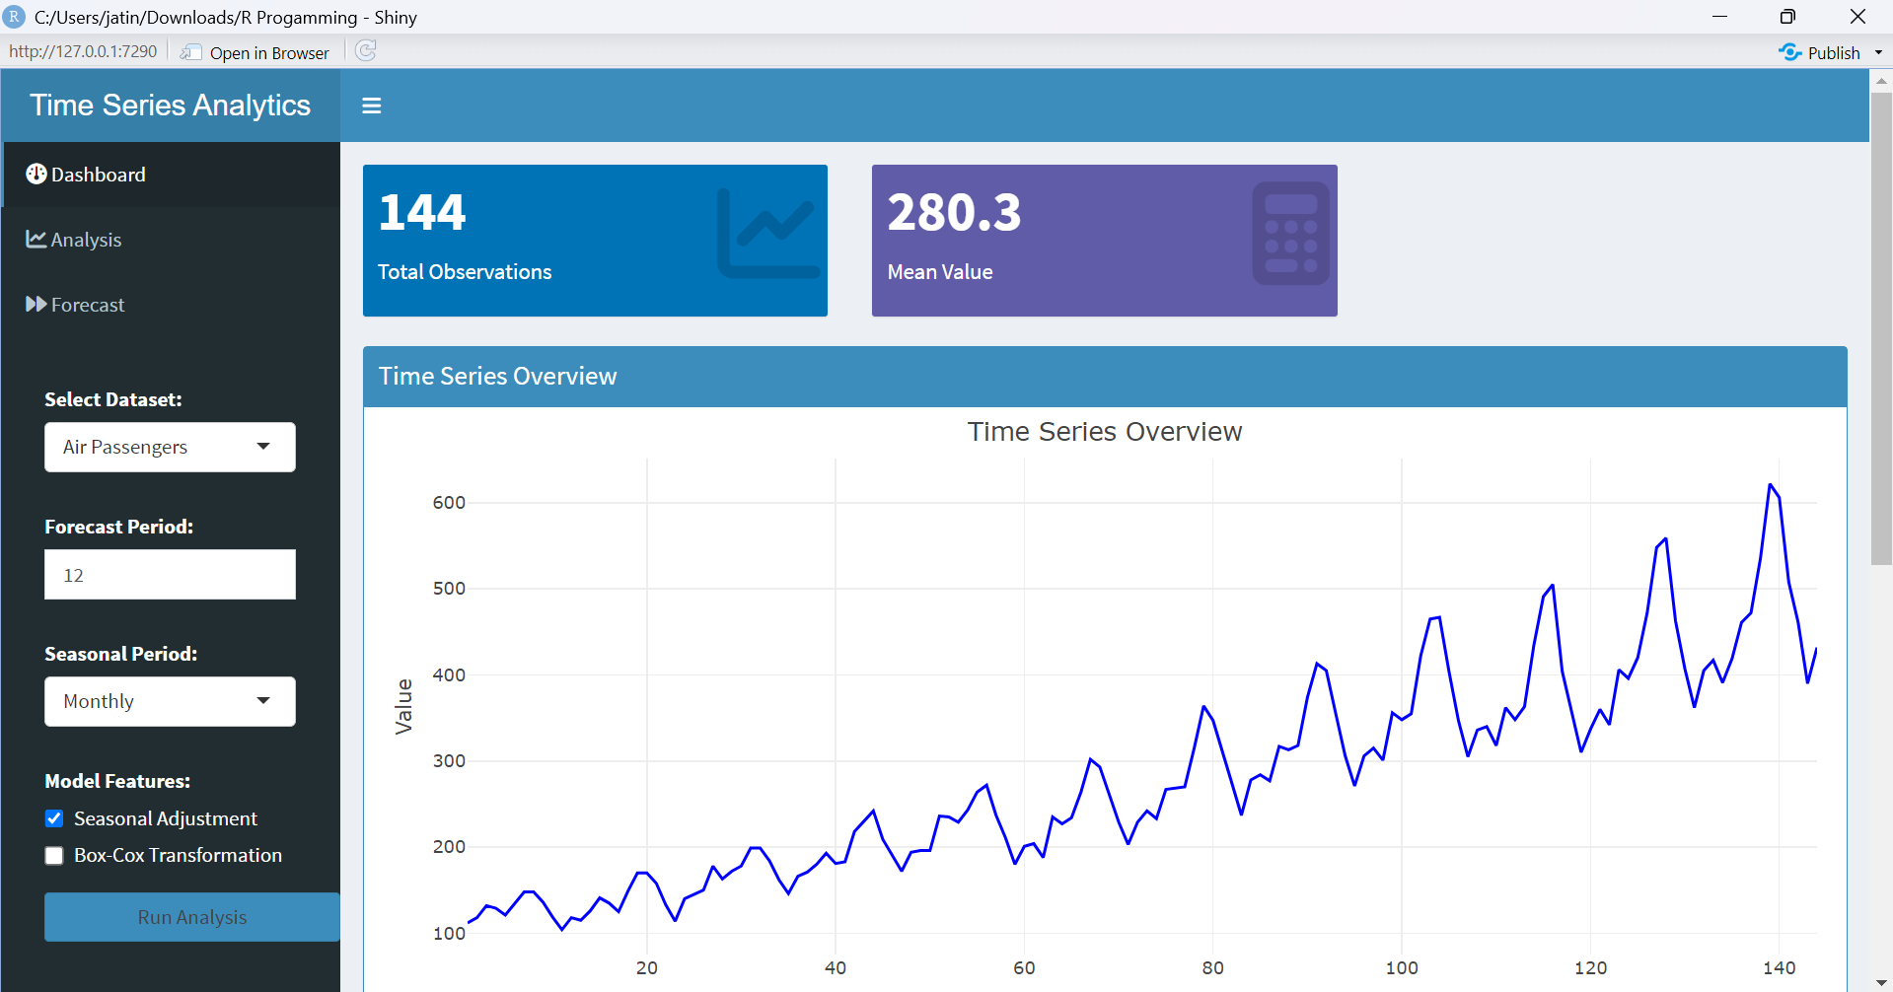

Fig 1. Dashboard of Analysis of Airline Passenger Data

**DATASET OVERVIEW**

**2.1 Data Description**

The primary dataset used in this project is the 'AirPassengers' dataset, which contains:

* Monthly airline passenger counts
* Time period: 1949 to 1960
* 144 total observations
* Seasonal patterns and trend components

**2.2 Data Characteristics**

* Frequency: Monthly
* Unit: Thousands of passengers
* Notable features:
  + Strong upward trend
  + Clear seasonal patterns
  + Multiplicative seasonal effects

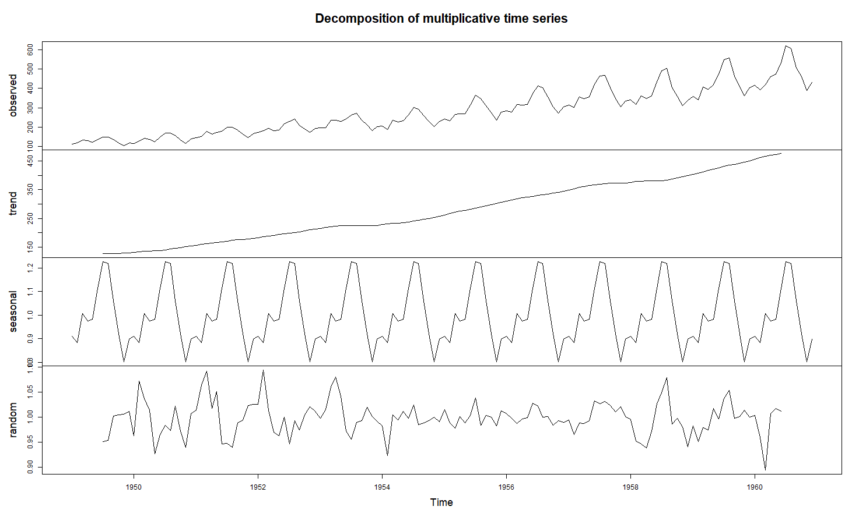

Fig 2. Time Series Decomposition

**2.3 Data Quality and Preprocessing**

* Completeness: 100% (no missing values)
* Consistency checks performed
* Time series object creation and validation
* Seasonal adjustment considerations

**2.4** **Air Passengers**  
Monthly totals of international airline passengers (1949-1960).

* **Frequency:** 12 (Monthly)
* **Features:** Strong seasonality and upward trend.

**2.5** **CO2 Levels**  
Atmospheric CO2 concentration data (1959-1997).

* **Frequency:** 12 (Monthly)
* **Features:** Seasonality with a steady increase over time.

**2.6** **Temperature**  
Annual mean temperatures in New Haven, CT.

* **Frequency:** 1 (Annual)
* **Features:** Non-seasonal, long-term trend analysis.

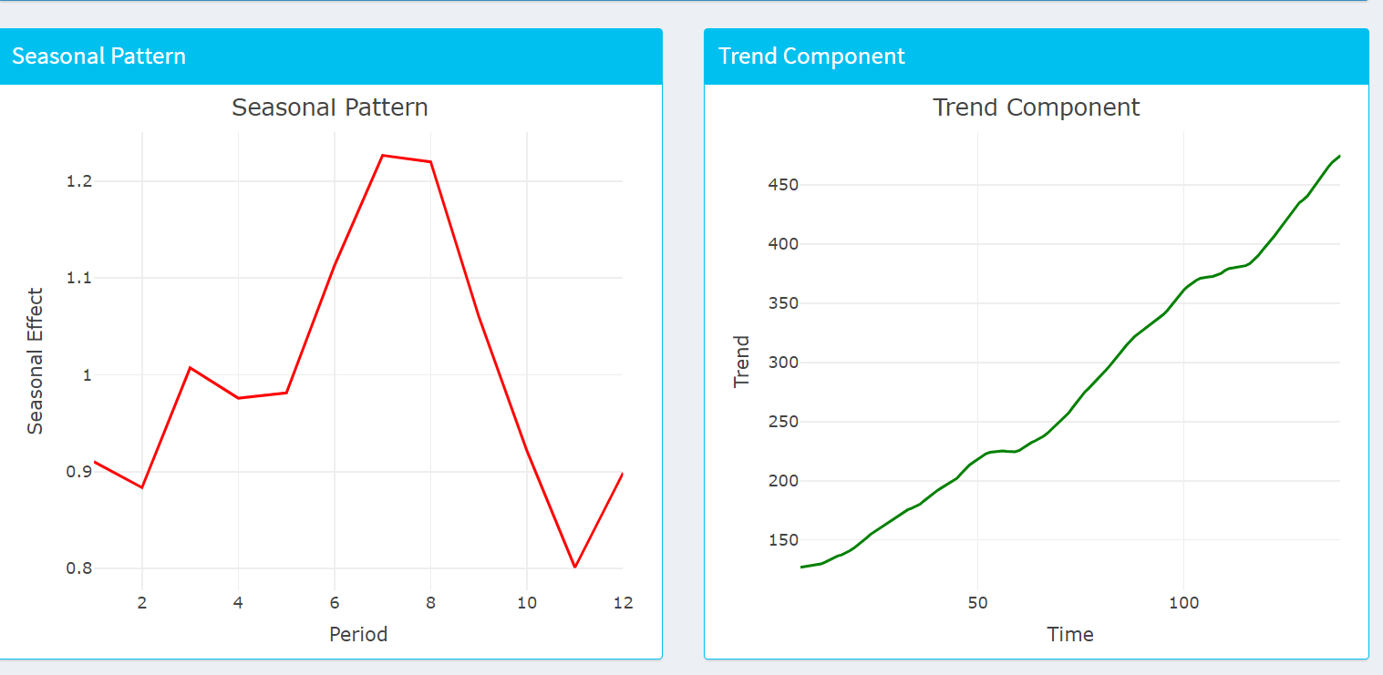

Fig 3. Seasonal Trend and Trend Component

**UNDERSTANDING TIME SERIES ANALYSIS**

**3.1 Time Series Components**

1. Trend Component
   * Long-term progression
   * Overall direction of the series
2. Seasonal Component
   * Regular patterns at fixed intervals
   * Monthly patterns in passenger data
3. Cyclical Component
   * Long-term oscillations
   * Business cycle effects



Fig 4. Time Series Decomposition

**3.2 Analysis Methods**

1. Decomposition Techniques
   * Additive decomposition
   * Multiplicative decomposition
   * STL decomposition
2. Statistical Tests
   * Augmented Dickey-Fuller test
   * Seasonal strength assessment

**3.3** **Time Series Basics:**  
Time series data captures observations indexed sequentially over time. Key components include:

* **Trend:** Long-term increase or decrease in data.
* **Seasonality:** Repeating patterns over fixed periods.
* **Residuals:** Random noise after removing trend and seasonality.

**3.4** **Modelling Tools Used in the Project:**

* **ARIMA (Autoregressive Integrated Moving Average):** A statistical model used to forecast time series data.
* **Decomposition:** Separates the time series into trend, seasonal, and residual components.
* **Statistical Tests:**
  + **ADF Test:** Checks stationarity of data.
  + **KPSS Test:** Detects trend stationarity.

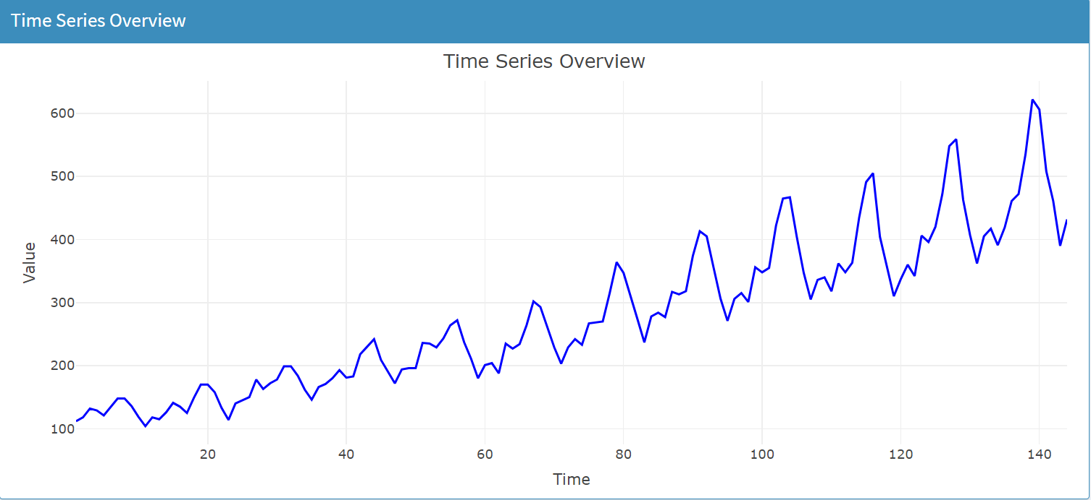

Fig 5. Time Series Overview

**TECHNOLOGIES AND TOOLS**

**4.1 Primary Technologies**

1. R Programming Language
   * Version: 4.x.x
   * Statistical computing environment
   * Extensive package ecosystem
2. Shiny Framework
   * Interactive web applications
   * Reactive programming model
   * Real-time visualization

**4.2 Key Packages**

1. Core Analysis
   * forecast: Time series forecasting
   * tseries: Time series analysis tools
   * stats: Statistical functions
2. Visualization
   * ggplot2: Statistical visualization
   * plotly: Interactive plots
   * shinydashboard: Dashboard layout
3. Data Manipulation
   * dplyr: Data manipulation
   * tidyr: Data cleaning
   * lubridate: Date handling

**DATA MODELLING APPROACH**

**5.1 Preprocessing Steps**

1. Data Loading and Validation

data("AirPassengers")

ts_data <- AirPassengers

1. Time Series Object Creation

# Convert to time series object

ts_data <- ts(data, frequency = 12)

**5.2 Model Selection**

1. ARIMA Models
   * Automatic parameter selection
   * Seasonal components
   * Box-Cox transformations
2. Model Parameters
   * p: Auto-regressive order
   * d: Differencing order
   * q: Moving average order

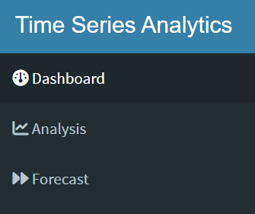 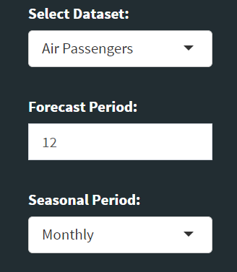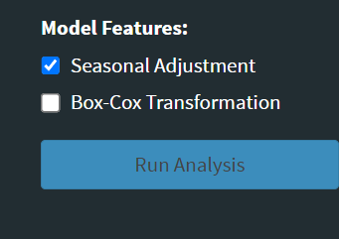

Fig 6. Model Selection and dataset selection

**BUILDING TIME SERIE ANALYSIS MODEL**

**6.1. Overview of UI and Server Components**

The UI is designed with a dashboard layout, including:

* **Sidebar:** Dataset selection, model configuration, and analysis triggers.
* **Main Panel:**
  + **Dashboard Tab:** Summary metrics, trend, seasonal, and overview plots.
  + **Analysis Tab:** Decomposition plots and statistical test results.
  + **Forecast Tab:** Forecast plot, model summary, and forecast metrics.

**6.2. Analysis Workflow**

* **Input Selection:** Users select datasets, forecast periods, and model features.
* **Time Series Decomposition:** Trend and seasonal components are extracted.
* **Model Fitting:** ARIMA models are applied with optional seasonal adjustment and Box-Cox transformation.
* **Forecasting:** Generate future values and evaluate metrics like MAPE.

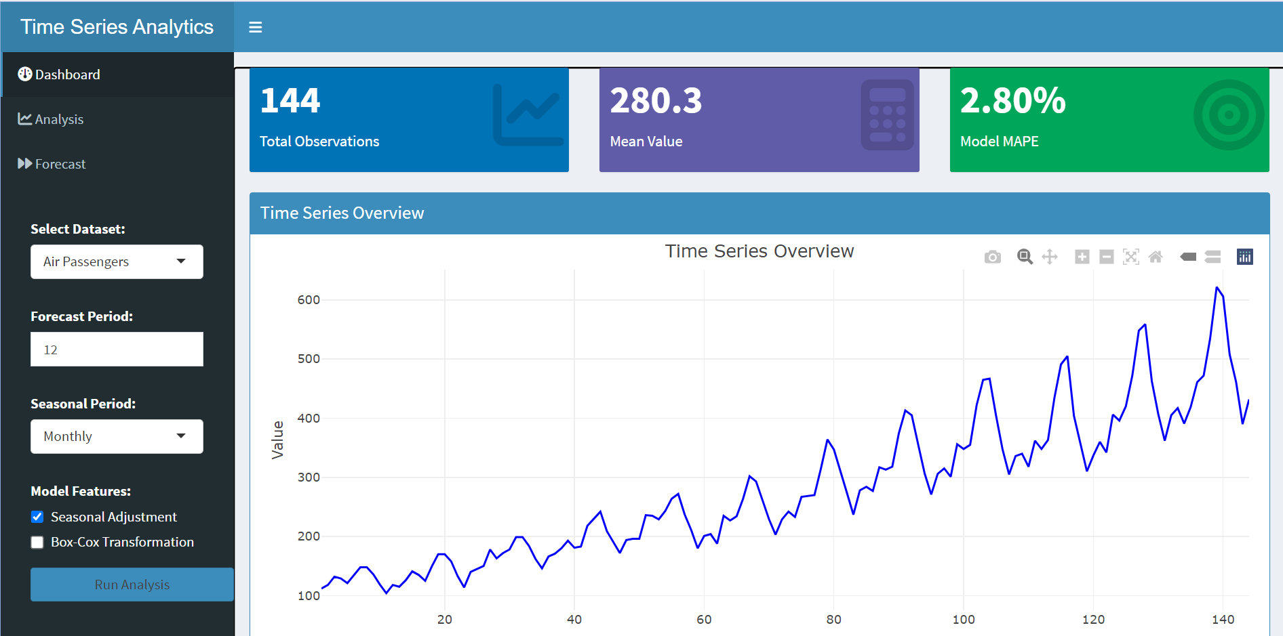

Fig 7. Dashboard UI with tabs for analysis and forecasting.

**MODEL EVALUATION**

**7.1 Performance Metrics**

1. Accuracy Measures
   * MAPE (Mean Absolute Percentage Error)
   * RMSE (Root Mean Square Error)
   * MAE (Mean Absolute Error)
2. Residual Analysis
   * Distribution of residuals
   * Autocorrelation checks
   * Heteroscedasticity tests

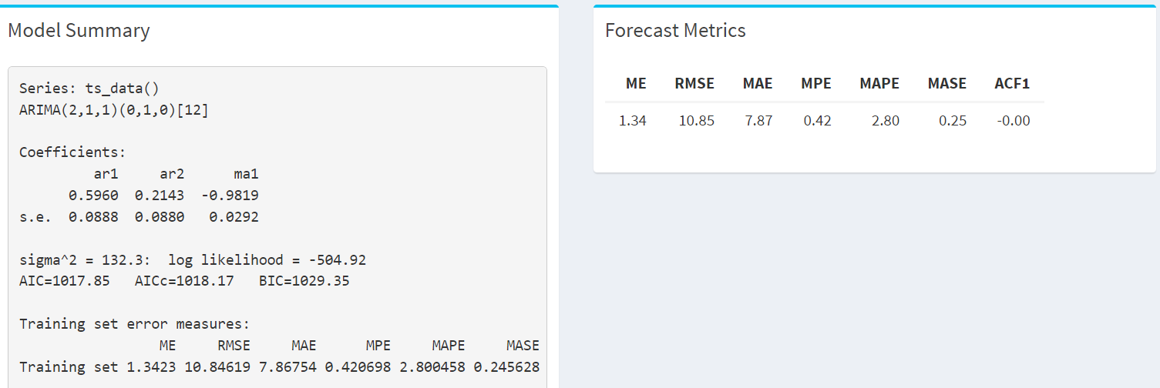

Fig 8. Model Performance

**7.2 Validation Techniques**

1. Cross-Validation
   * Time series cross-validation
   * Rolling forecast evaluation
   * Prediction interval assessment
2. Diagnostic Checks
   * Residual plots
   * Q-Q plots

**RESULTS AND ANALYSIS**

**8.1 Model Performance**

1. Forecast Accuracy
   * Overall MAPE: [Insert your value]
   * Prediction intervals coverage
   * Seasonal accuracy assessment
2. Comparative Analysis
   * Performance across different periods
   * Seasonal vs non-seasonal accuracy
   * Short-term vs long-term forecasts

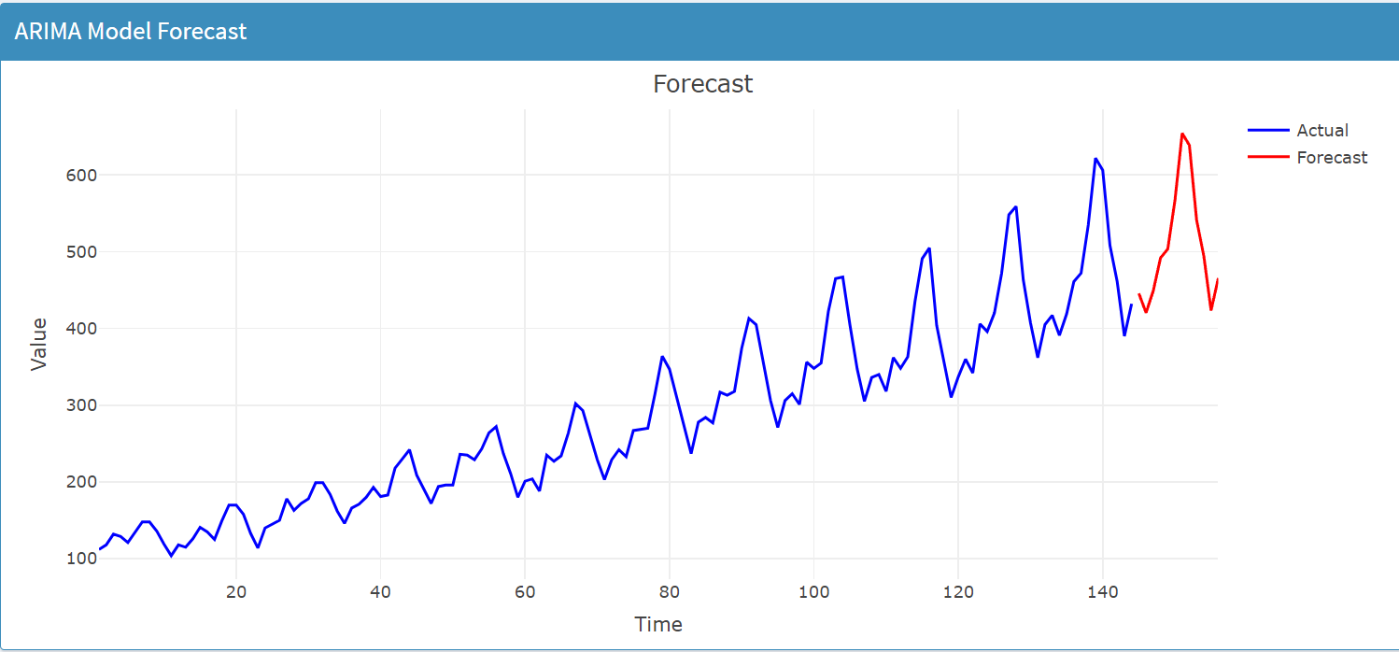

Fig 8. ARIMA Forecast Results

**8.2 Dashboard Features**

1. Interactive Elements
   * Real-time model updates
   * Parameter adjustment effects
   * Visualization controls
2. User Experience
   * Response time
   * Intuitive controls
   * Information accessibility

**8.3 Resultant**

* Visualize trends and seasonal patterns.
* Perform decomposition to identify time series components.
* Generate accurate forecasts for future observations.

Key Insights:

* Air Passengers data demonstrates clear seasonality.
* ARIMA effectively models and forecasts time series with minimal error.

**CHALLENGES AND LIMITATIONS**

**9.1 Technical Challenges**

1. Performance Optimization
   * Reactive calculation efficiency
   * Memory management
   * Plot rendering speed
2. Model Limitations
   * Handling extreme values
   * Complex seasonal patterns
   * Parameter selection trade-offs

**9.2 Data Challenges**

1. Seasonality Handling
   * Multiple seasonal patterns
   * Changing seasonal amplitudes
   * Holiday effects
2. Trend Complexity
   * Non-linear trends
   * Structural breaks
   * Level shifts

**9.3 Key Challenges**

• **Data Limitations:**  
The use of built-in datasets limits real-world applicability.

• **Model Flexibility:**  
ARIMA may not work well for all datasets, especially those with irregular patterns.

**CONCLUSION AND FUTURE WORK**

This project highlights the power of interactive dashboards for time series analysis and forecasting. The Time Series Analytics Dashboard provides an intuitive interface for exploring data, performing statistical tests, and generating forecasts.

**F**uture Enhancements:

* Integrate support for external datasets.
* Add advanced modeling options like Prophet and LSTM.
* Optimize UI for better performance with large datasets**.**

**10.1 Project Achievements**

* Successfully implemented interactive dashboard
* Robust time series analysis capabilities
* User-friendly interface
* Accurate forecasting system

**10.2 Future Enhancements**

1. Technical Improvements
   * Additional models support
   * Enhanced visualization options
   * Performance optimization
2. Feature Additions
   * Multiple dataset comparison
   * Automated reporting
   * Advanced diagnostics

**REFERENCES**

* **Hyndman, R.J., & Athanasopoulos, G.** (2021). *Forecasting: Principles and Practice*. OTexts. Available at: https://otexts.com/fpp3/.
* This book provides detailed insights into time series forecasting techniques like ARIMA and ETS models, used in this project.
* **Cleveland, R.B., Cleveland, W.S., McRae, J.E., & Terpenning, I.** (1990). *STL: A Seasonal-Trend Decomposition Procedure Based on Loess*. Journal of Official Statistics, 6, 3–33.
* The decomposition process used in this project is based on the STL decomposition approach, referenced here.
* **Box, G.E.P., & Jenkins, G.M.** (1970). *Time Series Analysis: Forecasting and Control*. Holden-Day.
* This seminal work explains ARIMA modeling, a key methodology applied in this project.
* **Shumway, R.H., & Stoffer, D.S.** (2017). *Time Series Analysis and Its Applications*. Springer.
* Provides fundamental concepts of time series analysis and modeling, including stationarity and seasonality.
* **R Documentation** (2024). "auto.arima() function in forecast package." R Project.
* Official R documentation for the auto.arima() function used for automated ARIMA modeling in this project. Available at: <https://www.rdocumentation.org/>.
* **Chambers, J.M., & Hastie, T.J.** (1992). *Statistical Models in S*. Chapman & Hall.
* Discusses statistical modeling approaches relevant for time series analysis and forecasting.
* **RStudio Shiny Documentation** (2024). "Creating Web Applications with Shiny."
* Documentation on Shiny app development, providing guidance on building interactive dashboards. Available at: https://shiny.rstudio.com/.
* **Lubridate Package Documentation** (2024).
* Acknowledges the use of lubridate for handling date-time objects effectively. Available at: https://lubridate.tidyverse.org/.
* **Plotly Documentation** (2024). "Interactive Data Visualization in R."
* Documentation for creating interactive time series visualizations using Plotly. Available at: https://plotly.com/r/.
* **Makridakis, S., Wheelwright, S.C., & Hyndman, R.J.** (1998). *Forecasting Methods and Applications*. Wiley.
* Explores advanced forecasting techniques and their practical applications in various domains.

**dv**